The Scottish Country Dance Group Basel
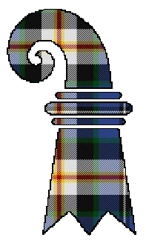
Scottish Country Dance Weekend
26th/27th November 2022

Application form

Name(s):................................................................................................................................
Address:..................................................................................................................................................................................................................................................................................................................................................................................................................................
Telephone:..............................................................................................................................
E-Mail:.....................................................................................................................................

I would like to attend | Price per person | Number of people | Total cost
Full weekend (course and ball) | CHF 240
Course only | CHF 150
Ball only | CHF 90

Vegetarian? Yes No

Remarks: ................................................................................................................................

................................................................................................................................................

................................................................................................................................................

Please send by 7th November 2022 to: secretary@scdgb.ch

